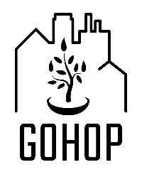
What is a Prayer Walk? A prayer walk is exactly what it sounds like. You get outside and pray as you walk around. There is a strange power when you connect your spiritual life to your body (in this case your feet). God is already up to some amazing things outside your door. Feel free to explore, pray and ask God lots of questions. Don’t forget to listen.
Where should I walk? Try starting where you have a connection. It could be around where you live, work, volunteer, or where your church meets. If you are practicing prayer walking as part of a group, you may want to pick out a route together (even if you are walking at different times). Try walking the same route more than once and think about what changes and what stays the same. It may also be helpful to debrief with the rest of your group. There might be something God is saying in what you all shared in common. You may also see God in the uniqueness of each person’s journey.
Dress for the weather! Try not to cancel if it is a little colder or wetter than you hoped. God may have something to show you that you would not have seen otherwise. That being said, be safe. You don’t need to travel in an ice storm, or head down every dark alley at night just to say that you did it. Be aware of yourself and your surroundings.
How to use this visual guide: Feel free to print this document or go to GOHOP.ca to get the “phone sized” version. The drawings & prompts in this guide are meant to spark your imagination. The goal is to get you thinking about all the ordinary things you might see on a walk that could prompt a small time of prayer. I suggest looking through the ideas in this guide before your prayer walk to see what inspires you. If one of my drawings gives you a different idea than I thought of, that is wonderful! When you are out walking, let God use your surroundings to shape your time of prayer.
Choose a tree. Thank God for the person who planted something others could enjoy. Thank God for the life this tree brings.  Try asking God, “What can I plant for my community?” | Keep your eyes open! What do you see around you? What might God be showing you? Every prayer walk is unique. Be open to respond to what you see. | Pray for the kids! Watch for parks, schools, and yards where children spend their time. Pray for the safety of the kids in the neighbourhood. Pray that they would each grow up knowing they are loved.
Pray to be shown a Person of Peace.  Every neighbourhood has one.  They often have a natural gift of  hospitality. They seem to know everyone.  A person of peace isn’t a Jesus follower  but they are open to honest & safe  conversations about God. | Do you see a property for sale?  Pray for the people or business that will be moving in next. Pray for the health & safety of your future neighbours.  © 2021 Randell Neudorf | God’s gifts come in all shapes and sizes!  Thank God for any animals you encounter.  What might God be teaching you  through pets, wildlife, and even the creatures we call pests?  Pray into any thoughts that come to mind.
.  Libraries (big & small) are places of connection & sharing.  Pray for the people who keep the shelves  stocked and the doors open.  Pray for all the people who visit seeking knowledge, stories, and belonging. | Pray for Churches in your neighbourhood. Some might own a building, others might meet in a home or a rented location. Every church tradition holds a unique gift. Ask God to show you something special about each church you encounter. | Watch for the small gifts.  Even the smallest objects in creation can point us to the Creator of the universe.  If something small catches your attention, take some time to wonder at the things that God has made.
Watch for Abandoned Spaces.  Ask God, “What are you dreaming  for this location?”  Pray for a kingdom-minded venture or  a person of peace to catch God’s vision for this neglected space. | Poop is gross, but we can flip the script! Is it dog poop? Pray for the dog walker. Perhaps they feel like, “No one cares so why should I?” If you think, it might be human poop, that is an invitation to pray about homelessness, addictions, and inequality. | What do you see that gives you hope?  It might be a building, a garden,  a person, or an animal.  Pray for where you see hope,  so that it might grow and spread.
Watch for people “Living Rough.”  The shelter system isn’t safe for everyone.  Be respectful, this is their home right now.  Remember they are beloved by God.  Pray for their safety & wellness.  Pray that they would obtain housing.  Pray that you would see with God’s eyes. | 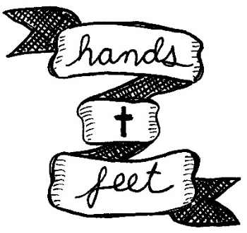  Pray for Ministries & Charities  that are the hands & feet of Jesus  in your community. Pray for the people that are served. Pray for the volunteers & staff. Pray for a beautiful dignity in both the giving & receiving.  © 2021 Randell Neudorf | Pray into Revelation 3:20,  “Behold, I’m standing at the door, knocking. If your heart is open to hear my voice and you open the door within, I will come in to you and feast with you, and you will feast with me.”  (Passion Translation)
Do you see any places to buy food?  It could be a grocery store, a market, a restaurant, or even a corner store.  Pray for the staff, they are frontline workers. Pray for access to affordable healthy food. Pray for the farmers & workers you can’t see. | If you hear a siren, pray for the safety & wellness of all.  Pray for first responders.  Pray for the person who called 911.  Pray for people without power or voice.  Pray for the help that is needed.  Pray for peace & life. | Use a stop sign to ask God a question.  Without any blame or shame ask God,  “Are there any stop signs from You  that I’m running through?”  If God brings something to mind,  ask a follow up question,  “ Lord, what is Your invitation to me in this?”
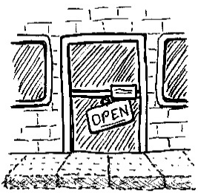  Businesses can shape a community.  Pray for owners & managers, that they  would seek the shalom (peace & wellness)  of the neighbourhood.  Pray for sustainable employment.  Pray for good businesses to prosper. | Pray for Affordable Housing. It could be a brand new project, a repurposed building, a laneway suite, or an individual home with an extra room  Land Acknowledgements in Hamilton speak of the “Dish with One Spoon” Wampum. An agreement,  “created to bind the Nations of the Haudenosaunee Confederacy to the Great Law of Peace. The Dish represents the shared land, while One Spoon reinforces the idea of sharing & peace.”  (McMaster Land Acknowledgements Guide)  Thank God for the seeds of peace planted here! | Every piece of graffiti (welcomed or not)  was made by a person who was made  in the image of their Creator. Pray for this person, that they would  feel seen and known by their creator.  Thank God for this person’s creative spirit.
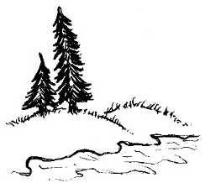  Watch for open spaces! Depending on your neighbourhood, these could be big or small, natural or concrete.  Use this open space as an invitation  to pause for a minute and be open to God (even if it is just a parking lot).  Watch for health care spaces.  It could be a big hospital or a small clinic.  Pray for the staff & patients.  Pray for wholeness & wellness for all.  Pray for a spirit of wisdom & grace  in the care given and received. |  | 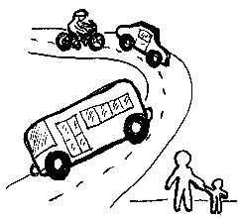  How are people getting around?  Pray for people using a mode of  transportation different than you would typically use. Think about the advantages & challenges. Use this to guide how you might pray.  Watch for lights! Let each light spark a quick little prayer. Feel free to meditate on John 1:5, “The light keeps shining in the dark, and darkness has never put it out”  (CEV Translation)
 | randellneudorf.com
© 2021 Randell Neudorf
This resource is available as a free download from:
gohop.ca/virtual-walks
randellneudorf.com/prayer-walking
Pay What You Can Online Donation:
https://www.canadahelps.org/en/dn/53164
Consider what you, your church or your organization
would normally pay for a similar resource.
If you are part of a little micro church, a church planter just scraping by,
or you could just use a free gift, don’t even think about a donation.
Projects like this are made possible by
Randell Neudorf’s growing monthly support team:
randellneudorf.com/gohop
Randell Neudorf is an artist, musician, and pastor. He has a fine arts degree from York University and is an ordained pastor with Mennonite Church Eastern Canada. That might sound like a strange combination but it is a perfect fit for his work with GOHOP (Greater Ontario House of Prayer), a new monastic ministry that believes prayer, creativity, justice, hospitality, mission and learning are all connected. Randell lives in a working class neighbourhood in Hamilton, Ontario with his wife Susan and their 3 children. A number of years ago the Neudorf’s gave up their car, so they do quite a bit of walking (along with biking, bussing and car sharing).

.
A Visual Guide To Prayer Walking
Resource & Drawings © 2021 Randell Neudorf
RandellNeudorf.com
Do not alter or reproduce this resource or drawings without permission from the artist.

